1. **Agenda**:
   1. What is Certificate?
   2. What info is included inside the certificate?
2. A certificate is a digital entity.  
   In fact, it is a file with simple data.
3. The following info is included in the certificate.
4. Information About Owner:
   1. Company Name, Web Site, Address etc.
   2. Sometimes serial number.
5. Information About Issuer:
   1. The info about CA or Intermediate CA that signs the certificate.
6. Signature:
   1. Certificate Data As Input **->** Hash Function **->** Hash Code -> Encryption Function -> Signature
   2. The Issuer generates the signature for a certificate.
7. 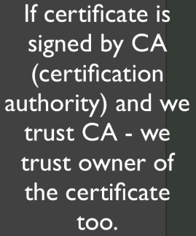
8. There are self-signed certificates.
9. The entire goal of certificate is to contain public key.  
   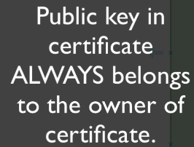
10. Private key is kept in secrete place and not found in certificate.
11. Brief:   
    